Part 1) Goal and Vulnerability Summary
This lesson demonstrates a broken authentication flaw in DVSA caused by improper JWT validation. The Lambda function behind the /order API decodes the JWT payload and trusts the username and sub claims directly, without verifying the token's cryptographic signature. The affected components are API Gateway and the order-handling Lambda. The impact is full user impersonation: any logged-in user can read another user's orders and personal details.

A JWT is header.payload.signature. The signature exists to prove that the payload hasn't been tampered with. The vulnerable handler skips that check entirely — it only base64-decodes the payload and reads the username from it. As a result, an attacker can edit the payload, leave the original signature in place, and the backend accepts the forged token as valid.

Part 3) Environment and Setup
DVSA was deployed in us-east-1. Two non-admin users were created — User B (attacker) and User C (victim) — and each placed at least one order. Tools used: browser DevTools, AWS CLI, curl, jq, and python3 for JWT decoding and forging.

Part 4) Reproduction Steps

Step 1 — Capture User B's API URL and token. Logged in as User B, opened DevTools → Network, clicked an order, and copied the request URL and the Authorization header. Saved both as API and TOKEN_B in the terminal.
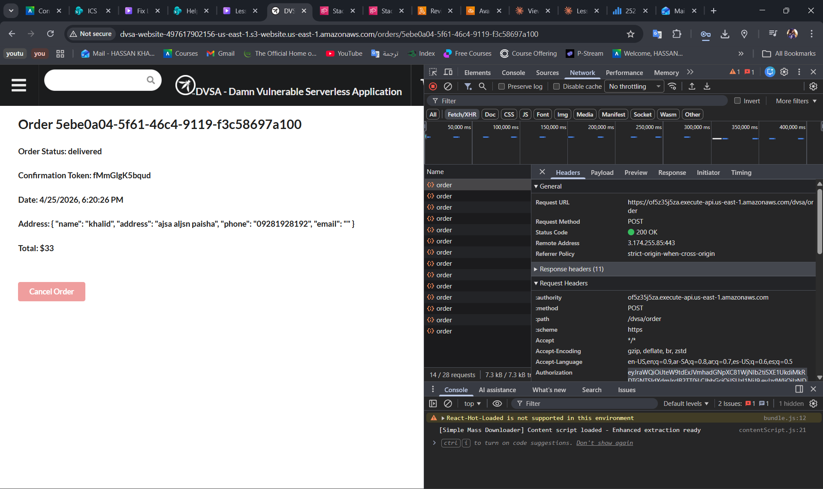
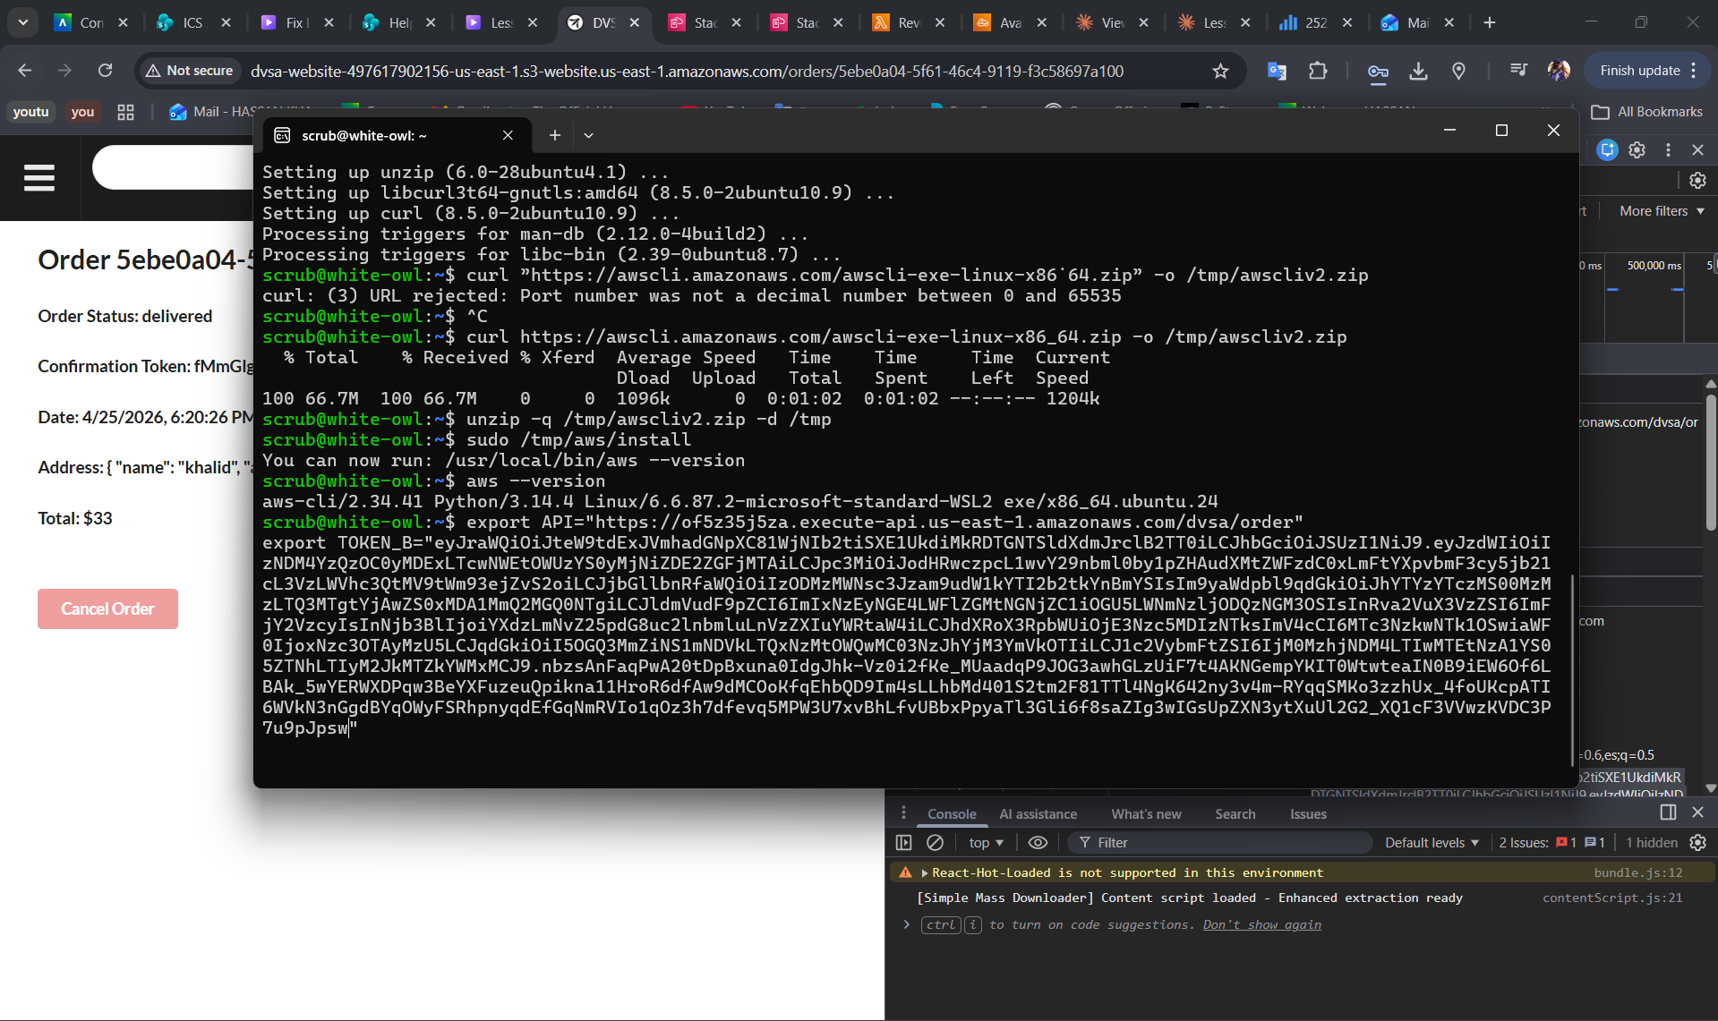
Step 2 — Repeat for User C. Logged in as User C and captured TOKEN_C the same way Step 3 — Decode both tokens and extract the victim's identity. A short Python script base64-decoded each token's payload and printed username and sub.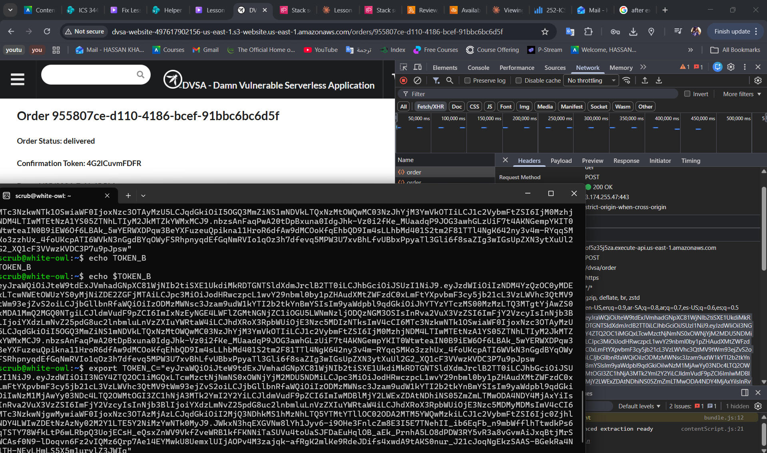

Step 3 — Decode both tokens and extract the victim's identity. A short Python script base64-decoded each token's payload and printed username and sub.
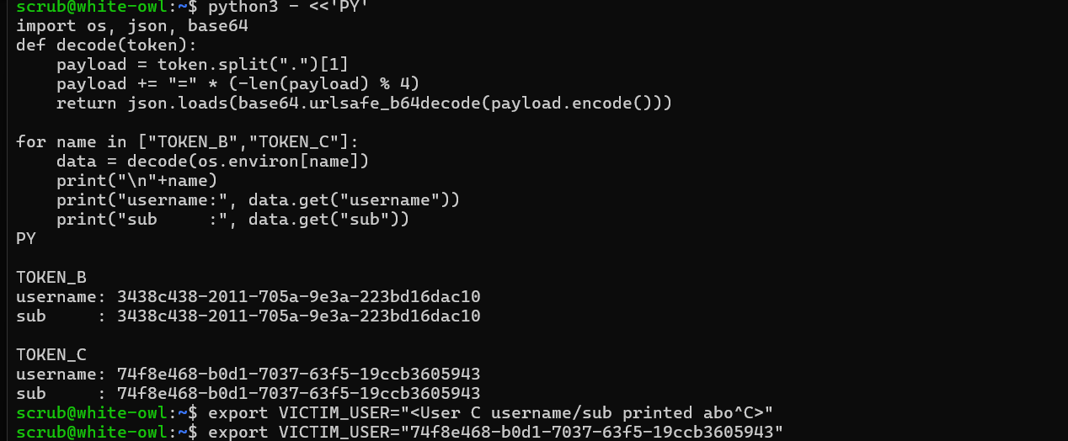

Step 4 — Forge the token. Took TOKEN_B, decoded its payload, replaced username and sub with the victim's identity, re-encoded the payload, and reattached the original header and signature unchanged. Stored the result as FAKE_AS_C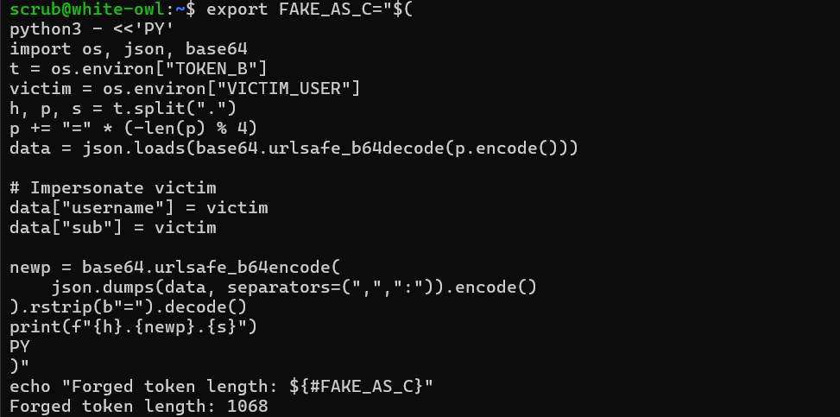
Step 5 — List the victim's orders. Called the /order API with action: "orders" using FAKE_AS_C. The response returned User C's order list — a confirmed impersonation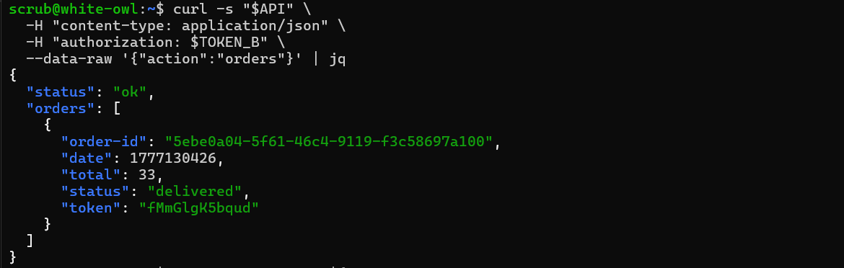

Step 6 — Retrieve full order details. Saved one of User C's order IDs as ORDER_C and called action: "get" with the forged token. The response leaked User C's name, address, phone, payment timestamp, and userId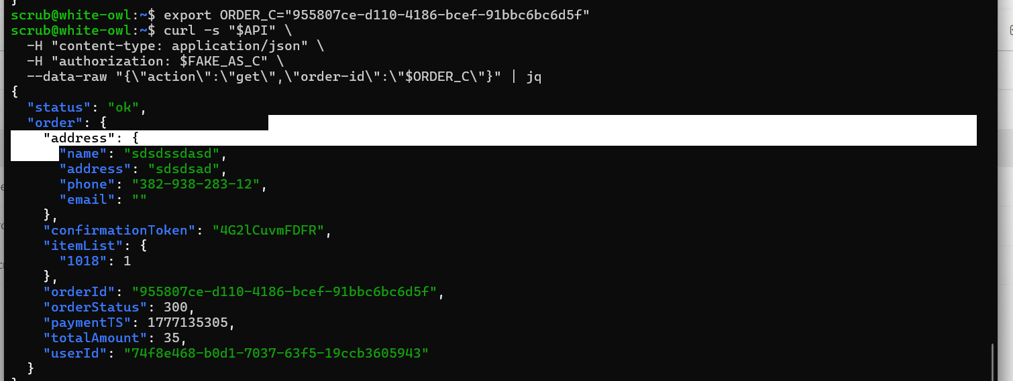
Part 5) Evidence and Proof
The forged-token request returned a complete order record belonging to User C — including the address "sdsdssdasd", phone "382-938-283-12", and userId: "74f8e468-b0d1-7037-63f5-19ccb3605943" — even though only the JWT payload was altered and the signature was never re-signed. This confirms the backend authorized the request based on unverified claims.
Part 6) Fix Strategy / Probable Mitigation
The fix belongs in the order-handling Lambda (DVSA-ORDER-MANAGER), specifically in the authorization step at the top of the handler. Instead of decoding the JWT payload and trusting it, the function must verify the signature against Cognito's public keys (JWKS) and validate the iss, exp, and token_use claims before any identity field is used downstream.

Part 7) Code / Config Changes
The patched Lambda imports node-jose and adds three helpers: fetchJson (HTTPS GET wrapper), getCognitoKeystore (fetches and caches the Cognito JWKS for 6 hours), and verifyCognitoJwt (cryptographically verifies the signature and validates issuer, expiry, and token use) (page 5).
The handler itself was rewritten to strip any Bearer prefix, return 401 missing authorization if no token is present, and call verifyCognitoJwt(jwt) before reading claims.username. The promise chain is closed with a .catch() that logs the failure and returns 401 invalid token (page 6, top). File changed: index.js of the DVSA-ORDER-MANAGER Lambda.

Navigate DVSA manager
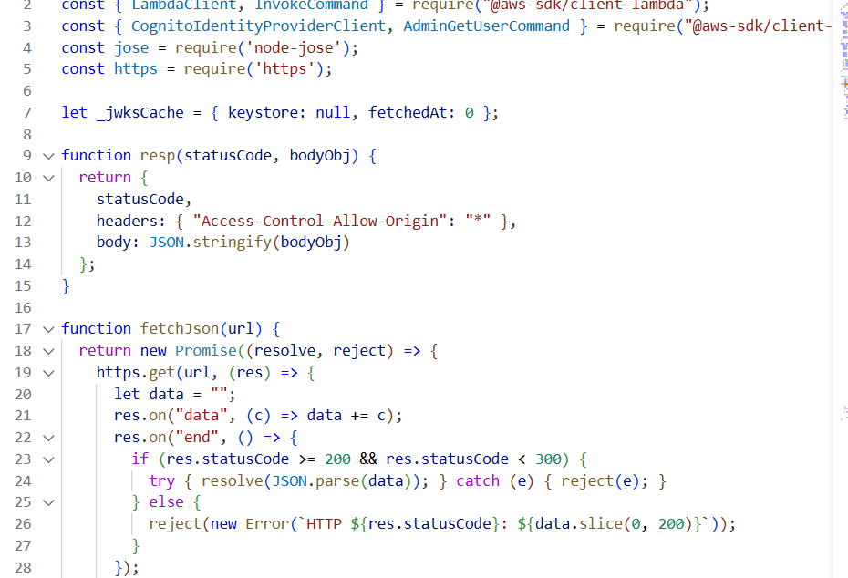

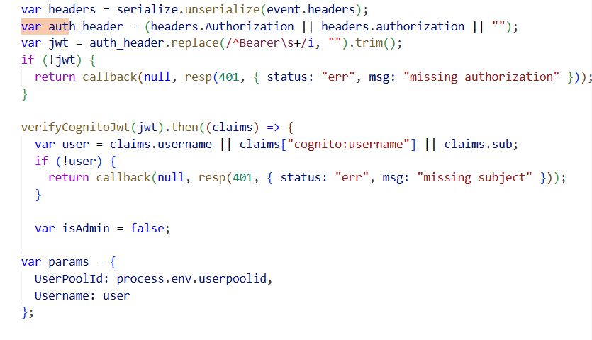
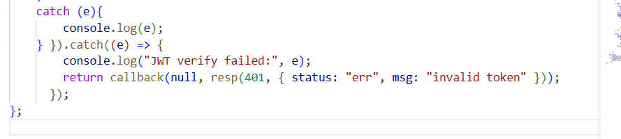
Part 8) Verification After Fix
The same forged token from Step 6 was replayed against the patched endpoint. The response was now:
{ "status": "err", "msg": "invalid token" }
The signature verification rejected the tampered payload, so no victim data was returned. A legitimate request using an unmodified TOKEN_B continued to return only User B's own orders, confirming that legitimate functionality was preserved.

Part 9) Structured Operation and Security Analysis

Table A — Intended vs. Actual Behavior
Vulnerability | Intended Rule | Artifacts Used | Normal Behavior | Exploit Behavior
Broken Authentication | Only a valid, signature-verified JWT may determine user identity; User B must not see User C's orders. | DevTools network capture, captured /order request, decoded JWT payloads, exploit response, Lambda source. | TOKEN_B returns only User B's orders. | FAKE_AS_C (modified payload, original signature) returns User C's order list and full order details.

Table B — Deviation, Fix, and Verification
Vulnerability | Why This Is a Deviation | Deviation Class | Fix Applied | Post-Fix Verification
Broken Authentication | The backend trusted identity claims from a JWT whose integrity was never verified. Attacker-controlled claims were used to authorize access to another user's data. | Intentional misuse / security-relevant abuse | Verify JWT signature against Cognito JWKS and validate iss, exp, and token_use before reading username/sub. | Forged token now returns 401 invalid token; legitimate token still works correctly for the rightful owner.

Part 10) Takeaway / Lessons Learned
Broken JWT validation is not a minor oversight — it's a direct path to account impersonation. In a serverless architecture, once the wrong identity is trusted at the entry point, every downstream Lambda inherits that false identity and acts on the attacker's behalf. The general rule is: a JWT's payload must never be trusted until its signature has been cryptographically verified against the issuing identity provider's public keys.

